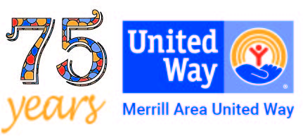
MERRILL AREA UNITED WAY, INC.
Merrill Area United Way, Inc.
P.O. Box 813
Merrill, WI 54452
715-536-2016
Delores.Olsen@merrillareaunitedway.org
September 2023 -- Foto News Article
Merrill Area United Way
Dee Olsen, Executive Director

IT’S UNITED WAY FALL CAMPAIGN TIME!
Last week every mailbox in Lincoln County, except the City of Tomahawk, should have received the Annual Appeal to provide funding through Merrill Area United Way. We only do this request once a year, making it very important for us to financially support the 20 agencies/programs that “make a huge difference” in the lives of many people. This is your opportunity to make a real difference to help people.
Also, this past week we held the Annual Appreciation Picnic for our funded agency representatives to formally recognize the wonderful work they do. The conversations were enlightening as we heard about the extreme cases/clients our agencies are working with to find solutions for some very difficult circumstances. The conversations certainly underscore some very dire needs as well as the significance of “Living United,” and “working united.” Our agencies collaborated and pooled their resources to find resolutions and get to the deep root of helping people.
Bottom line, what this means, United Way needs to have a very successful fall campaign for the upcoming 2024 year to sustain this incredible level of work.
United Way’s goal is $230,000 for this fall campaign. With that money we will make allocations for critical services that would not otherwise be available here in the Merrill area.
YOU are part of the WE!!! But we cannot have any impact without YOU. Your generous heart and financial support are what makes the difference. The donations for United Way come from individuals, families, retirees, fundraisers, employee campaigns and companies. The annual public appeal was just mailed to all households and businesses in Merrill and throughout Lincoln County. The agencies programs serve people in the areas of education, health, and basic needs, which may include, avoiding eviction with rental assistance, food to feed the family, utility payments to avoid shut offs, and so much more.
We only ask once a year for your donation. Can we count on you to do a little something this year? Every dollar helps and it all stays local. Please give generously and help your neighbors, family, and friends. If this is not a time for you to give, remember United Way accepts donations year-round. Mail donations to Merrill Area United Way, at P. O. Box 813, Merrill 54452. Our website is www.merrillareaunitedway.org where Pay Pal donations can now be made. For more information email us at delores.olsen@merrillareaunitedway.org ; or call our part-time office at 715-536-2016.

